|  |  |  |  |  |  |
| --- | --- | --- | --- | --- | --- |
| **Test Case Id: 1** | | **Test Purpose: verify requirement – Lecturer must be able to create an assessment** | | | |
| **Environment: written in Python 3.7, Windows 10 OS** | | | | | |
| **Preconditions:** Logged in as a lecturer on the main lecturer menu. | | | | | |
| **Test Case Steps: Basic Flow** | | | | | |
| Step No | Procedure | | | Response | Pass/Fail |
| 1 | Click the **“Start new test”** button | | | Displays the new test screen like in the figure below | Pass |
| 2 | Enter test details as follows: | | | New test file created with the  details entered. | Pass |
|  | 2.1 Enter “**JavaScript** **Test Example”** in the **“Title”** field | | |
|  | 2.2 Check **“Summative”** radio button | | |
|  | 2.3 Enter the release date in the **“Release date”** field as **15/04/2019.** | | |
|  | 2.4 Enter the due date in the **“Due date”** field as **01/05/2019** | | |
| 3 | Click **“Add new multiple-choice question”** button | | | Displays the new multiple-choice screen like in the figure attached below | Pass |
|  | 3.1 Enter in the **“Question Text”** field the question **“Which of the following are capabilities of functions in JavaScript?”** | | |  | Pass |
|  | 3.2 Enter in the **“Answer”** field **“Accept parameters”** | | |  |
|  | 3.3 Enter in the **“Incorrect options”** fields **“Return a value”**, **“Accept parameters and return a value”** and **“None of the above”** | | |  |
| 4 | Click **“Add new text answer question”** button | | | The system saves automatically the details entered for the previous question and appends a new row to the test file with the details of the new question. | Pass |
|  | 3.1 Enter in the **“Question Text”** field the question **“In what HTML element you put JavaScript?”** | | |  | Pass |
|  | 3.2 Enter in the **“Answer”** field **“script”** | | |
| 4 | Click “Save and finish adding questions” | | | Displays a message “Test Saved” like in the figure attached below    ######## | Fail |
| **Comments:** | | | | | |
| **Related Tests: Log in to the system** | | | | | |
| **Author: Team 22** | | | **Checker: Panayiotis Kkolis** | | |

|  |  |  |  |  |  |
| --- | --- | --- | --- | --- | --- |
| **Test Case Id: 2** | | **Test Purpose: Lecturer must be able to modify the formative or summative assessments.** | | | |
| **Environment:** Python 3.7, Windows 10 OS | | | | | |
| **Preconditions:** Lecturer is already logged in. An assessment has not been submitted yet. | | | | | |
| **Test Case Steps:** | | | | | |
| Step No | Procedure | | | Response | Pass/Fail |
| 1 | Select **Edit test** | | | The system should load a new page with options **Formative** and **Summative** |  |
| 2 | Select either **formative** or summative depending on which test you want edited. | | | The system should open the formative or summative assessment that has not been submitted yet. |  |
| 3 | The question: “**What property of a class describes a range of values that instances of the property may hold?”** Should be edited to **Which HTML attribute specifies an alternate text for an image, if the image cannot be displayed?”** | | | The system should accept the change and the new question should be displayed. |  |
| 4 | Next select **Answer Text** and change answer from “**attribute**” to “**longdesc”** | | | The system should accept the change and the new answer should be accepted. |  |
| **Comments:** After a test becomes available to students the Lecturer can only modify the Question text in case of spelling mistakes. He cannot change possible answers as a student might have already submitted his answers. | | | | | |
| **Related Tests: Log in to the system** | | | | | |
| **Author: Team 22** | | | **Checker: Panayiotis Kkolis** | | |

|  |  |  |  |  |  |
| --- | --- | --- | --- | --- | --- |
| **Test Case Id: 3** | | **Test Purpose:** Enable a student to take a summative assessment | | | |
| **Environment:** Python 3.7, Windows 10 OS | | | | | |
| **Preconditions:** Student is logged into the system to be able to take a test  . The summative test is made available to the student by the lecturer. | | | | | |
| **Test Case Steps:** | | | | | |
| Step No | Procedure | | | Response | Pass/Fail |
| 1 | Select a test by clicking on Take Test | | | The test will start and display the following :( Figure 1 at the end of this test case) | Pass |
| 2 | Fill in answers into the displayed spaces | | | For each question, there is a space below for your answer. (see Figure 1) | Pass |
|  | 2.1 For the first question, “**Are CSS property names…”,** you input yes**”** | | |  |  |
|  | 2.2 For the question, **“What is the use of the only selector?”**, you should enter **“Choice 1”** | | |  |  |
|  | 2.3 For the question, ”How can you clear a float element**”** you should enter **“Choice 1”** | | |  |  |
|  | 2.4 For the question, **“Which of the following is described as a collection of images put in a single image?”** you should enter “**Choice 1**” | | |  |  |
|  | 2.5For the question “**A collection of data containing both properties and methods is called:”** you should enter “**Choice 1”>** | | |  |  |
| 3 | Select submit test | | | Test should end and results saved in the system |  |
| 4 | You will now only have the option to **View Answers**. | | | By clicking View Answers, the system should display your mark, your mark is 3View Marks |  |
| **Comments:** The system returns with feedback from the test after the attempt is completed. | | | | | |
| **Related Tests:** Log in to the system  Create a test | | | | | |
| **Author: Team 22** | | | **Checker: Panayiotis Kkolis** | | |

**Figure 1**

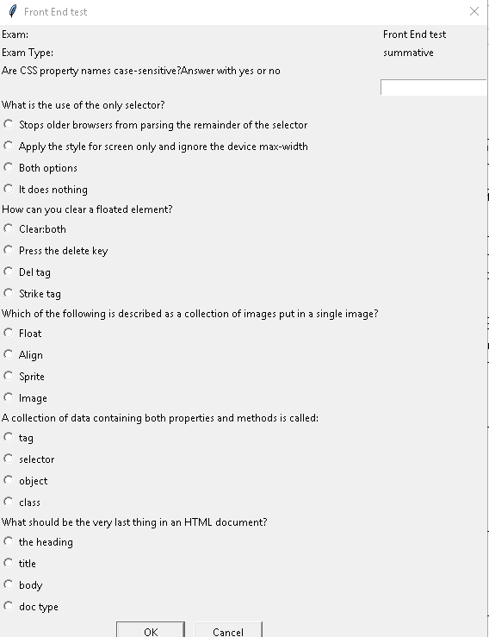

|  |  |  |  |  |  |
| --- | --- | --- | --- | --- | --- |
| **Test Case Id: 4** | | **Test Purpose: verify requirement – enable a student to take a formative test** | | | |
| **Environment: written in Python 3.7, Windows 10 OS** | | | | | |
| **Preconditions: Student is logged into the system to be able to take a test.**  **The formative test is made available to the student by the lecturer.** | | | | | |
| **Test Case Steps: Basic flow** | | | | | |
| Step No | Procedure | | | Response | Pass/Fail |
| 1. | Select OOP test test by clicking on **Take Test** | | | Displays the test like in the figure attached below (see Figure 1 at end of test case) | **Pass** |
| 2. | Fill in the test  2.1 For the first question, “**What can represent an object in real world? Please select one of the following”,** you should select **‘All the above”** | | | For each question, there is space available for your answer. |  |
|  | 2.2 For the question, **“What property of a class describes a range of values that instances of the property may hold?”** you should enter **“attribute ”** | | |  |  |
|  | 2.4 For the question, **“Which visibility attribute indicates that data can only be accessed within the class?** you should enter “**private**” | | |  |  |
|  | 2.4 For the question,”**Which of the following is not part of OOP**”you should choose “**private**” | | |  |  |
|  | 2.5For the question “**Constructors are used to**:”you should choose “**operations**” | | |  |  |
|  | 2.6 For the question” **An Object that has more than one form is referred to as an**:” You should choose “**Abstract Class**” | | |  |  |
| 3. | You have the option to either select **Attempt again** or **View Answers** | | | The system displays two labelled buttons at the bottom of the window, like in the figure attached below  ######### | **Fail** |
|  | 3.2 Select **View Answers** as this is your only and final attempt | | | Once you submit your final attempt by clicking on **View Answers**, the system displays the questions in order and their answers as shown in the figure attached below  View Marks | **Pass** |
| **Comments:** | | | | | |
| **Related Tests: Log in to the system**  **Create a test**  **The lecturer can view statistics about cohort’s performance on formative tests.** | | | | | |
| **Author: E Vaipan** | | | **Checker: Panayiotis Kkolis** | | |

**Example for future reference: The system returns to the test without displaying a feedback for the attempt.**

**Figure 1**

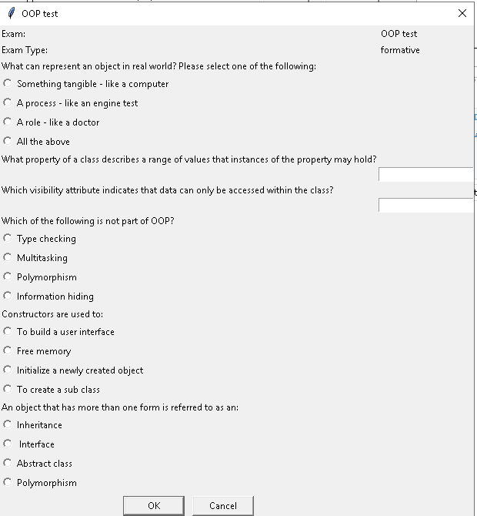

|  |  |  |  |  |  |
| --- | --- | --- | --- | --- | --- |
| **Test Case Id: 5** | | **Test Purpose: View statistics of performance of a test** | | | |
| **Environment:** Python 3.7, Windows 10 OS | | | | | |
| **Preconditions:** Student is logged into system  A test is already completed | | | | | |
| **Test Case Steps:** | | | | | |
| Step No | Procedure | | | Response | Pass/Fail |
| 1 | Select **View Marks** button for the required test. | | | The system should display results for test selected. | Pass |
| **Comments:** | | | | | |
| **Related Tests: Log in to the system** | | | | | |
| **Author: Team 22** | | | **Checker: Panayiotis Kkolis** | | |

|  |  |  |  |  |  |
| --- | --- | --- | --- | --- | --- |
| **Test Case Id: 6** | | **Test Purpose: verify requirement - the lecturer can view student performance on summative assessments** | | | |
| **Environment: written in Python 3.7, Windows 10 OS** | | | | | |
| **Preconditions: Lecturer is logged in**  **ExampleResults.csv exists in results directory** | | | | | |
| **Test Case Steps: Basic flow** | | | | | |
| Step No | Procedure | | | Response | Pass/Fail |
| 1. | Navigate to the results section for the **Web Applications** test by clicking **View Results** button for the required test. | | | Main page reloads and results page shows like in the figure attached below  View Results | Pass |
|  |  | | |  |  |
| 2. | Select **“Summary of marks for all students”.** | | | The system displays a list of the students’ IDs, names, and their marks | Fail |
|  |  | | |  |  |
| 3. | Select **c100002** to see this student’s individual performance. | | | The system displays individual report for this specific student as shown in the picture below  ######## | Fail |
|  |  | | |  |  |
| **Comments: Log in to the system**  **Create a test** | | | | | |
| **Author: Saif** | | | **Checker: Panayiotis Kkolis** | | |